- See the file ‘assignment_data_series.xlsx’ to find the data series (plural!) you have been allocated (released by the end of Friday, August 7). Read up on the MARTIN model using the assigned PDFs, and check Table 1 and the appendix (of the research paper) to see how the variables in the model (corresponding to your data series) are specified (i.e. levels, logs or %) and where the data is sourced from. List the details about the series, including name, source, abbreviation. Describe in one or two sentences what each data series is about/ captures. [1 mark]
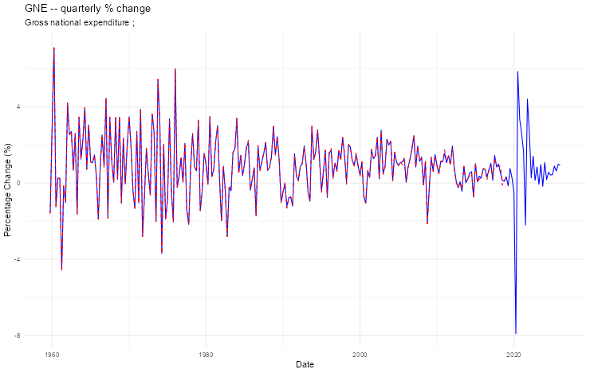
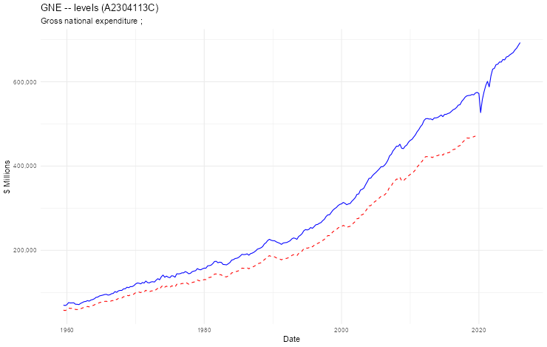
Gross national expenditure (GNE)

- Find the most recent vintage of each data series from the relevant source up until Q1 2026 (even if more recent data is available!). This should be done using code in R using either the readabs or readrba packages.

- For each assigned data series, plot the original and updated data against each other. If the series has a clear trend in level terms (e.g. GDP or consumption) plot the quarterly % changes too. [1 mark]

- For each assigned data series, describe any outliers in the original sample, the COVID-19 period, and any revisions made to the pre-COVID sample. [1 mark]

- Finally, for each assigned data series, upload the R code. The code should be a separate file which downloads the data, transforms it, and appends it to the MARTIN data file. [2 marks]

